25-02-2010
George K. Aidoo
SM/SMS/09/0019
Physics Practical

Experiment 1

Wheatstone Bridge Experiment

AIM:

To determine unknown resistances, total resistance of resistors in series, and total resistance of resistors in parallel.

APPARATUS:

Slide measuring bridge (1), connection box (1), standard PEK carbon resistor (1), unknown PEK carbon resistors (5), power supply, 5 V/1 A, +/-15 V (1), digital multimeter 071340.00 (1), three 500mm connecting cords (2 each; red, yellow and blue).

DIAGRAM:

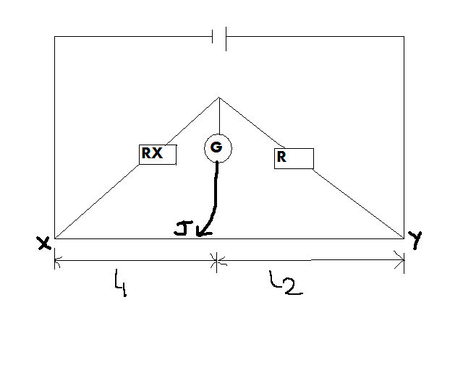

THEORY:

The Wheatstone bridge is an instrument used accurately for measuring resistance and comparing them. At balanced point, the potential at C equals the potential at J, and no current flows through the digital multimeter. The potential difference across R equals the length l₂ and the potential difference across R_{X} equals l_{1.}

Then:
R/ R_{X} = l₂/ l₁ AND R_{X}=R (l₁/ l₂)

For resistor R₁ and R₂ in series, R_{X}= R₁+R₂.
For resistor R₁ and R₂ in parallel, 1/R_{P}= (1/ R₁+1/ R₂). R_{P} can then be determined by expanding the equation as follows:
1/R_{P}= (R₁+ R₂) / ( R₁R₂)
R_{P}(R₁+ R₂) = ( R₁R₂)
Thus, R_{P}= ( R₁R₂) / (R₁+ R₂)

PROCEDURE:

In the experiment, the values of the resistors to be determined are made invisible and encoded as follows: A, B, C, D, and E. The resistance to be investigated (single, parallel-connected and series-connected) are as shown in the above diagram. Resistor A and the standard resistor R were connected using the connection box. Switching on the power supply, the correctness of the connection was checked by touching the bridge the bridge wire at the extreme ends (X and Y) with the slider jockey, J and the negative and positive readings of the digital multimeter G was observed. The position where there was zero reading on the multimeter represented the balanced point. The lengths l₁ from the end X to the balanced point was measured.
The procedure was then repeated for the rest of the unknown resistances B, C, D, and E. After that unknown resistors A and B were connected in series and then in parallel, and their values were recorded. Because the side wire measuring bridge gives the best reading accuracy in its central part, the measuring resistance R was brought to order of the magnitude of R_{X}. The multimeter, G (setting 100mA = 100mV), was balanced by moving of the slider.

TABLE OF RESULTS (Observations):

L₂ / cm | L₁ / cm | Unknown Resistance
67.9 | 32.1 | A
93.9 | 6.1 | B
98.6 | 1.4 | C
97.0 | 3.0 | D
99.1 | 0.9 | E

Unknown resistors A & B in series with R=10Ώ:
L₁ / cm = 6.3
L₂ / cm = 93.7

Unknown resistors A & B in parallel with R=10Ώ:
L₁ / cm = 5.5
L₂ / cm = 95.5

Calculation of Unknown Resistors:
Using the formula from the theory, the values of the unknown resistors can be determined as follows;

Unknown resistor A: R_{X}=R (l₁/ l₂)
R_{X} = 10Ώ x 32.1cm/67.9
R_{X} = 4.7 Ώ
Therefore, A = 4.7 Ώ

Unknown resistor B: R_{X}=R (l₁/ l₂)
R_{X} = 10Ώ x 6.1cm/93.9cm
R_{X} = 0.65 Ώ
Therefore, B = 0.65Ώ

Unknown resistor C: R_{X}=R (l₁/ l₂)
R_{X} = 10Ώ x 1.4cm/98.6cm
R_{X} = 0.14 Ώ
Therefore, C = 0.14Ώ

Unknown resistor D: R_{X}=R (l₁/ l₂)
R_{X} = 10Ώ x 3.0cm/97.0cm
R_{X} = 0.31 Ώ
Therefore, D = 0.31Ώ

Unknown resistor E: R_{X}=R (l₁/ l₂)
R_{X} = 10Ώ x 0.9cm/99.1cm
R_{X} = 0.10 Ώ
Therefore, E = 0.10Ώ

Resistors in series:
Using the formula in the theory and the calculated values of resistors A and B, the value for these resistors in series is determined as follows:
R_{s}= A+B
R_{s}= 4.7 Ώ + 0.65Ώ = 5.35 Ώ

Resistors in parallel:
Using the formula in the theory and the calculated values of resistors A and B, the value for these resistors in parallel is determined as follows:
R_{P}= (AB) / (A+ B)
R_{P}= [(4.70 Ώ)(0.65Ώ)] / [4.7 Ώ + 0.65Ώ]
R_{P}= (3.06 Ώ²) / (5.35 Ώ)
R_{P}= 0.57 Ώ

DISCUSSION:

From the result of the resistances determined in this experiment, the length from point X at which the multimeter was balanced is directly proportional to the magnitude of the resistance determined. The greater the distance of the jockey from the point X, the greater the value of the resistance.
Determination of the resistors A and B in series and in parallel showed that resistance is greater in a series than it is in parallel.

SOURCES OF ERROR:

- Error of parallax may have occurred when readings were being taken from the galvanometer.

- Errors may have occurred because of delaying in opening the key on the connection box after readings were taken.

PRECAUTIONS:

- The connections were made very tight to avoid any errors in the readings.

- The reading of the balanced point was repeated to make sure of accurate readings of the length.

CONCLUSION:

The values for the unknown resistors and the values of two of the resistors in series and in parallel were successfully determined using the Wheatstone bridge instrument.

REFERENCES:

ATTAKORAH, Paul; Electric and Magnetic Fields and Atomic and Nuclear Physics, Kumasi: Modern Printing Press, 2006, pages 110 – 111.

